FILM STUDIES MINOR
REQUIREMENTS

In consultation with the program director, students design a program of study that includes a range of film genres, styles, national cinemas, eras and disciplinary and methodological approaches. Students are strongly encouraged to take at least one course addressing topics in global or non-western cinema. The minor consists of a total of six courses and must include the following:
• One introductory course in the formal analysis of film (e.g., ENGL 205 - Intro to Film, HART 170 – History of Narrative Cinema)

• One course in film history or an area of film history (e.g., HIST 284 – Movies & America, RUSS 258 – Soviet & Eastern European Cinema)

• One course in film theory or an area of film theory (e.g., ENGL 306 - Film Theory, HART 235 – Identification in the Cinema)

• Three electives
At least one of the six courses must be at the 300 level. Courses that fall into two or more of the above categories may fulfill the requirement of the student’s choosing, but may not fulfill more than one requirement simultaneously. Students should consult with their advisers and deans to determine which courses, if any, may count simultaneously for multiple credentials (for the Minor, no more than two courses may be double-counted with the student’s major). Final approval is at the discretion of the program director.

THE BRYN MAWR COLLEGE
MINOR IN FILM STUDIES

The Film Studies Minor at Bryn Mawr College provides students with a background in the history, theory, criticism, and production of moving images, with an emphasis on the analysis and interpretation of cinema as a key form in modern visual culture. The program emphasizes film as a formal system with its own set of clearly identifiable properties and conventions, which nevertheless invites unique opportunities for interdisciplinary study. Course offerings are drawn from English, History of Art, French, Italian, German, Russian, Spanish, History, and the Creative and Performing Arts, giving students access to a range of interpretive methodologies, national cinemas, and film styles and genres.

The student who minors in Film Studies acquires the critical skills central to the discipline. Through contact with the materials and methods of her major, she also develops intellectual, cultural and political perspectives that broaden the angle of critical vision. Students also have the opportunity - unique to a program like Bryn Mawr's - to experience every level of the curriculum in small classes, with intense, focused discussion, close contact with faculty, frequent and challenging writing assignments, technologically sophisticated learning conditions, and opportunities for guided research.
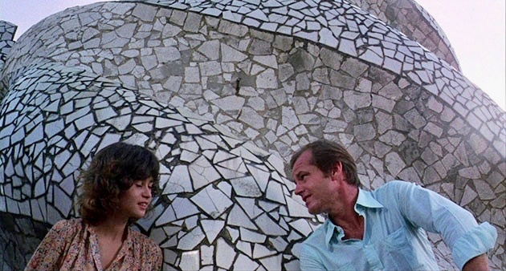

The Bryn Mawr College

Program
in Film Studies

2023-2024

Contact Information

Director: Julien Suaudeau
jsuaudeau@brynmawr.edu
Office: Old Library 149
Administrative Assistant: Margaret Kelly
mkelly01@brynmawr.edu
Office: Old Library 235
Program website

Film Studies Courses
2023-2024

FALL – BRYN MAWR

ENGL 232 Race on Film – From Student Movements to BLM (Daniels) MW 11:40a-1:00p
ARCH 246 Classical Antiquity in Movies (Palermo) MW 2:40p-4:00p
SPAN 252 Compassion, Indignation, and Anxiety in Latin American Film (Gaspar) TTh 9:55a-11:15a
ARTW 266 Screenwriting (Torday) T 1:10p-4:00p, screening S 6:00p-9:00p
GERM 321 Advanced Topics in German Cultural Studies – Asia and Germany through Film (Shen) MW 1:10p-2:30p
HART 376 Topics in Interpretation & Theory – 20th C. Theories of Signs and Images (King) W 2:10p-4:00p
FALL – HAVERFORD
EALC 231 Postwar Japanese Cinema (Schoneveld) TTh 1:00p-2:25p

ANTH 275 Race & Representation in Documentary Filmmaking (Sertbulut) TTh 11:30a-12:55p
VIST 141 Digital Media Pre-Production (Woodard) MW 2:30p-3:55 (1st half semester)
VIST 241 Film & Digital Media Editing (Woodard) MW 2:30p-3:55p (2nd half semester)
FALL – SWARTHMORE
FMST 001 Critical Approaches to Media (Simon) F 2:00p-5:00p, screenings Th 7:00p-10:00p
FMST 011 Advanced Digital Production (Evans) W 1:15p-4:00p
FMST 015 Screenwriting (Evans) Th 1:15p-4:00p
FMST 041 Fan Culture (Rehak) M 1:15p-4:00p
FMST Animation and Media (Rehak) TTh 11:20a-12:35p, screenings M 7:00p-10:00p
FMST 050 Critical Approaches to World Cinema (White) TTh 2:40p-3:55p, screenings 7:00p-10:00p

SPRING – BRYN MAWR
HART 170 History of Narrative Cinema, 1945-present (King) TTH 12:55p-2:15p
FREN 208 La diversité dans le cinéma français contemporain - Minorités invisibles (Suaudeau) MW 1:10p-2:30p
GERM 217 Representing Diversity in German Film (Shen) MW 1:10p-2:30p
ARTD 220 Screendance: Movement and the Camera (Fishel) TTh 9:55a-11:15a
HART 235 Identification in Cinema (Feliz) MWF 10:10a-11:00a, screenings Su 7:10p-10:00p
ITAL 238 Italian Society in Film (Bozzato) MW 1:10p-2:30p
ENGL 294 Masterpieces in Iranian Cinema (Dabashi) MW 2:40p-4:00p

ENGL 357 A Star is Born – Race, Gender, and Celebrity
(Dabashi) MW 1:10p-2:30p
SPRING – HAVERFORD
VIST 110 Foundations in Film Production (Muse) MW 10:00a-11:25a
WRPR 111 Power, Place, and Film (Ladva) MW time TBD
SPAN 210 Spanish & Spanish American Film Studies (Castilla Sandoval) W 1:30p-3:44p
ANTH 239 Visions of Justice – Intersectionality & Legal Consciousness in Asian Cinema (Hong) TTh 10:00am-11:25a
ANTH 277 Media & the Middle East (Sertbulut) TTh 2:30p-3:55p

SPRING – SWARTHMORE
FMST 002 Digital Production Fundamentals (Evans)
FMST 020 Critical Theories of Film and Media (White)
FMST 0225 Television Studies (Simon)
FMST 035 Video Game Design and Creation (Rehak)
FMST 090 Film and Media Studies Capstone (Rehak)

All courses are subject to change; please check the Trico Course Guide. Last updated 8/15/23.

